11 Objectives of Advertising – What are Advertising Objectives?
May 11, 2019 By Hitesh Bhasin Tagged With: Marketing management articles
Advertising is one of the most creative fields and is a part of Marketing. In fact, Advertising has become so big that many people get confused about the differences between marketing and advertising. Nonetheless, the objectives of Advertising are completely different from Marketing.
In summary, it is the objective of advertising to carry out communications between the brand and the customer. Before the adoption of digital marketing and advertising, most of the communication between the brand and the customer was one way. However, nowadays even digital advertising like sponsored ads are a chance of two-way communication.
Without further ado, we present to you the 11 objectives of advertising and the goals which advertising can achieve for an organization.
Table of Contents

11 Objectives of Advertising
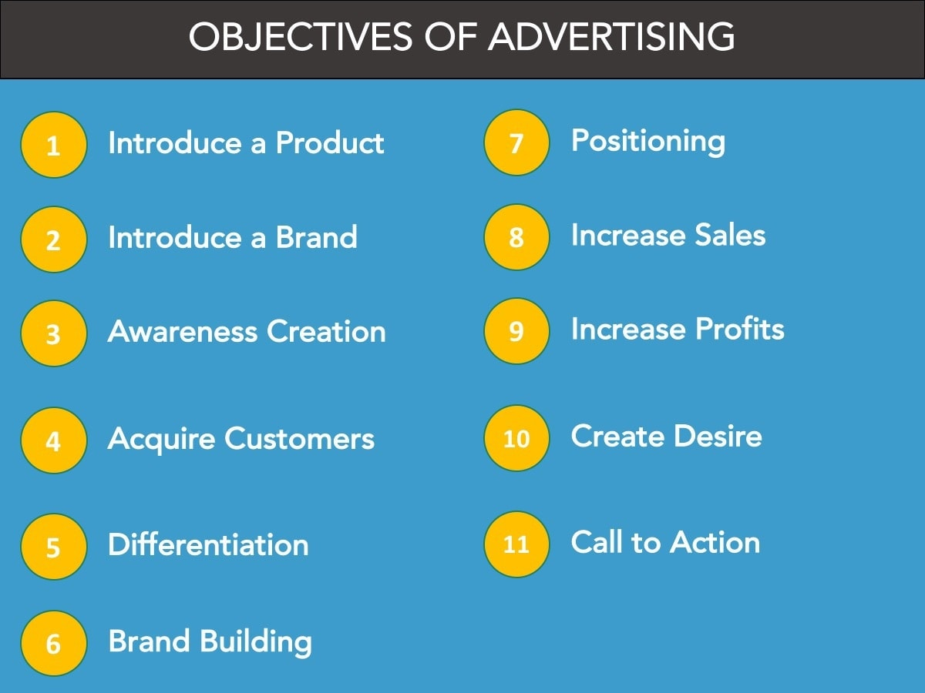

1) Introduce a product
The most common reason Advertising is used is to introduce a new product in the market. This can be done by existing brands as well as new brands. Have a look at the latest IPhone in the market or a Samsung smartphone and you will find a lot of advertisement for these new products. The objective of advertising here is to tell customers – “Here is the new product we have launched”

2) Introduce a brand
There are many startups in the market today and many of them are services. Services are generally marketed as a brand rather than marketing their individual service product. Thus, Uber will market its own brand and introduce that Uber has started servicing customers in a new market. Same goes for Oracle or Accenture – Companies which market their brand and their presence in the market rather than marketing an individual product.

3) Awareness creation
According to the AIDA model, the most important job of advertising is to get attention which is nothing but Awareness creation. Advertising needs to capture the attention of people and make them aware of the products or their features in the market.
Ad by Valueimpression
Example – Most of the Bank ads that you see are awareness campaigns. The ads that advertise the benefits of savings / mutual funds or benefits on credit and debit cards are all awareness creation ads.

Also Read Lifestyle Segmentation

4) Acquiring customers or Brand switching
One of the major objectives of advertising and the first objective of many advertising campaigns is to acquire more customers. This is also known as making the customers switch brands. This can happen by passing on a strong message so that the potential customer leaves the brand which he is tied up with and comes to your brand.
Example – Most telecom companies launch plans and strategies just to acquire customers and then advertise these strategies in the market so that the customer switches brands. There is hardly any differentiation in the telecom market – thus advertising is a major way to acquire customers. The Vodafone Zoozoo campaign was just that – Influence the customers and create passion in such a way that they do brand switching,

5) Differentiation and value creation
A most important aspect of Advertising is to differentiate the product or the service from those of the competitor. A customer can only differentiate between services based on the value the firms provides over that of competitors.
If a competitor is just advertising the features, whereas your firm advertises the promises and commitments that it will keep, naturally more customers will “trust” your brand over others. This is the reason that advertising is used commonly to create value and to differentiate one brand from another.
Coca cola, Toyota, Amazon are some of the most trusted brands in the market. It is no doubt that these brands are also amongst the top advertisers in their respective segments. These brands target value creation as well as differentiation via their advertising campaigns.

6) Brand building
When a brand regularly advertises and delivers quality products and fulfills the promises it makes, automatically the value of the brand is built. However, there are many other aspects of brand building. One of the first ones is to advertise via ATL and BTL campaigns etc.
Ad by Valueimpression
Brands have different objectives of Advertising. Brands like P&G and HUL regularly invest funds in building a good brand value for the parent brand. By doing so, even if one brand is affected, the parent brand is untouchable.
Recently we observed the problems of Maggi in India where Maggi was banned completely due to high lead content. However, this did not affect the parent brand Nestle much and neither affected its other brands like Nescafe which had done their own brand building and were independent of the parent brand. This brand was built by good products and constant advertising towards building brand equity and making a connect with the audience.

Also Read Customer Development

7) Positioning the product – Product and brand recall
One of the key factors in the actual purchase of a product is the products recall and the brand recall at the time of purchase. Amongst the objectives of advertising, one objective is to correctly position the brand in the minds of the customer.
Examples include premium brands like Ralph Lauren, Gucci, Hermes or others which are clearly positioned premium. This position is achieved by first having a very premium product line which is high priced but it is also achieved by buying premium advertising and placing the ads in media vehicles which are very premium.
Besides premium marketing, we can also look at niche marketing. Kent is a company which has focused all its advertising on its purification capability. They claim they are the masters of water purifiers. Their repeated advertising creates a high product and brand recall in the minds of the customers thereby positioning them as the top purchased brand in the water purifier segment.

8) Increase sales
Naturally, with so many steps being taken to advertise the product, it is no doubt that one of the objectives of advertising is to increase sales. Many a times this objective is achieved via advertising. However, if the campaign is improper or the audience is not targeted properly, then advertising can fail in its objective.
Nonetheless, there are many seasonal products wherein an immediate increase in sale is observed due to advertising. The best example is Ice cream brands which advertise heavily during the summer months because they know that advertising will immediately influence the sales figures. They do not waste money in advertising during the winter season at all.
Ad by Valueimpression
Similarly, you will see many ads of raincoats during rainy season and ads of winter wear during winter seasons. All these ads are placed to increase the sale of the product immediately.

9) Increase profits
With the value being communicated and the brand being differentiated as well as sales being increased, there is no doubt that advertising can contribute a lot to increasing profits. Advertising should never be looked at as an expense or a liability. In fact, it is an investment for a firm just like a brand is an investment.
Look at the likes of Siemens or Bosch – Brands which have invested heavily in positioning themselves on the basis of their German engineering. As a result, today they demand high profits in whatever segments they operate in or whatever products they sell.

Also Read Market follower strategies

10) Create Desire
Again, referring to the AIDA model, one of the key factors in advertising is to create a desire for the product so that the customer wants the product. Brands which are known to do this are BMW, Audi, Harley Davidson, Adidas and others. These brands are master of advertising where they create so much desire for the product that the customer absolutely wants a product even if he doesn’t need it.
There are many stories of Harley Davidson as a brand wherein customers have saved money for years to buy a particular bike of Harley Davidson. Same stories can be heard about an Audi or a BMW. A unique example in this case are the bottles of Absolut Vodka. Absolut Vodka is so famous for its bottles that there are collectors who desire to collect all different bottle types of Absolut Vodka. Such desire creation is an effect of advertising + brand building + the fan following over time.

11) Call to action
One of the most common objectives of digital advertising and digital marketing is to get a call to action. Brands invest in banner ads, link ads as well as social ads to get their potential customers to take an action. This action can be filling up an Email form, clicking on a link, watching a video, giving a survey or what not.
There are brands which have done ATL advertising and shown half the ads and then attracted customers to their YouTube channel so that they could track their viewers and get them to take some action. Call to actions are also one of the objectives of advertising in which case the actions differ from time to time based on what the marketer wants to achieve.
Ad by Valueimpression

Video on Role of Advertising
The above are the different types of Objectives of Advertising. Naturally, a firm can have 2-3 objectives for advertising their products or services.
Some of these objectives might be short term like advertising to increase seasonal sales whereas other objectives might be long term like Brand building and increasing profits. Depending on the current standing of the firm in their market, they can choose their advertising objective and come up with an advertising campaign.
31Shares
1 Advertising Objectives Objectives Provide a platform for clients, agency accounts executives and the creative team to communicate Also helps to coordinate efforts of copywriters, radio/TV specialists, media buyers and research specialists Sales as an objective: Advertising is one of the influencing factors along with product features, packaging, consumer taste, competition, distribution and price Long term objective includes changing attitudes and improve image
2 Advertising Objectives Operational Objectives: Target segment Ultimate behavioral change intended Role of advertisement in the process of change Reinforcing loyalty of existing users For developing Ad Objectives an understanding of Consumer Behavioral Dynamics is essential Brand associations New customers from other categories Price elasticity Increasing usage
3 Advertising Objectives Customer types: Existing customers Those not buying the product class Those buying other brands exclusively Using more than one brand (credit cards, footwear, clothes, automobiles etc): “Share of Requirements”
4 Ad Response Variables Models LoyaltyBrand attitude (like-dislike feeling) LoyaltyAssociate brand with user type Sales leads to sales via personal sellingStraight advertising LoyaltyAssociate feelings and brand use Sales via personal sellingKnowledge about company Increase usageKnowledge of new applications Trial purchase Loyalty Knowledge of brand attributes leading to trial purchase Brand awareness Behavioral variableIntervening variable
5 Ad Communication Effects 90%: Awareness 70%: Knowledge 40%: Liking 25%: Preference 25%: Trial 5%: Use
6 Advertising Objectives Multiple objectives: “Compensation Principle” of William McGuire (psychologist) states that single ads should not aim at more than one objectives Multiple objectives may involve Different and complementary ads Different target audience Target segments have great influence in setting ad objectives For selecting and quantifying objectives and to measure performance DAGMAR approach is used
7 The DAGMAR Approach Defining Advertising Goals for Measured Advertising Results: Russell H. Colley Advertising Goal: a specific communication task, to be accomplished among a defined audience, in a period of time Effects model of the communication process UnawareAware Comprehension and Image Attitude Action
8 The DAGMAR Approach Other Communication Models: AIDA Attention gain Interest create a Desire precipitate Action New Hierarchy Model conceived by rural sociologists (5 stages) Awareness Interest Evaluation Trial Adoption
9 The DAGMAR Approach Other Communication Models: Hierarchy Model conceived by Robert Lavidge and Gary Steiner as components of attitude Cognitive or knowledge component of attitude Awareness Knowledge Affective component of attitude Liking Preference Conative component of attitude Conviction Purchase
10 The DAGMAR Approach Concrete and Measurable Communication Tasks Well-defined Target Audience Have an Existing Benchmark Measure Specify Degree of Change Sought Specify Time Period
11 The DAGMAR Approach Checklist of Promotional Tasks: To what extent does the ad aim at immediate sales Does the ad aim at near-term sales by moving the prospect step by step closer to sale Does the ad aim at building a long-range consumer bonding How important are supplementary benefits of end- use advertising (help build morale of sales reps, impress trade, aid sales people to get sales)
12 The DAGMAR Approach: Difficulties Response Hierarchy problems Does not always define the process people use to reach purchase/use Attitude – Behavior Relationship Attitude change does not always lead to change in actions or behavior Costly and Impractical: The research and efforts cost more than the results are worth Inhibition of Creativity: Too many rules and structure curb genius Sales Objectives: Immediate sales expectations

